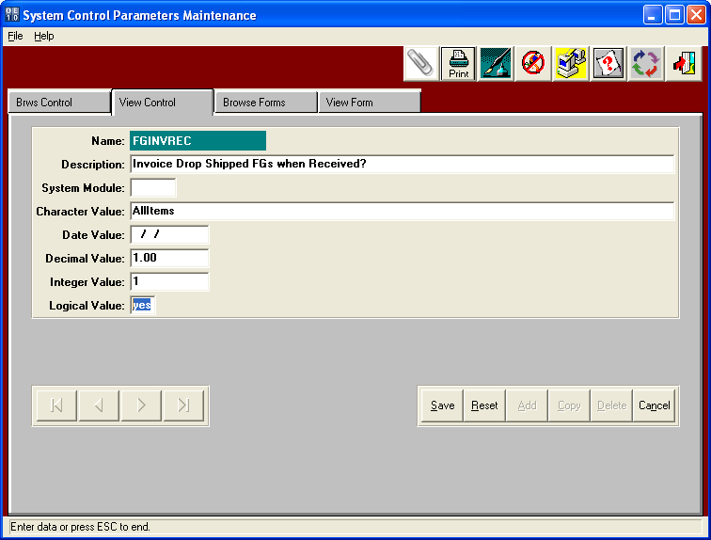

FGINVREC - Invoice Drop Shipped FGs when Received?

This option will create an Invoice for finished goods receipts for purchased finished goods that were created as a drop shipment to a customer. This logic would save many steps for purchased finished goods dropped shipped, which simply place purchase orders then invoice the delivery.

LOGICAL VALUE - When the logical value is YES, finished goods posting will automatically create an Invoice for Finished Goods receipts via purchasing with a purchase order type of D for Drop Shipped. First an purchase order is created for a finished goods that is purchased as a drop shipment type purchase order. Therefore, the vendor on the purchase order will deliver the finished goods directly to the to the customer. When the vendor notifies the box maker that the goods have been delivered, the finished goods receipt should be entered. The finished goods receipt will prompt "Create Invoice for Drop Shipped Purchase Order? YES. Will flag the item during FG posting to automatically update the release quantity to the finished good receipt quantity, post the release and post the bill of lading, which will create the invoice. The bill of lading will have the same warehouse / bin location as the finished goods receipt.